Jalu Chaudhary

Class IT-314-DL1

Hand on Assignment

1.Create a list that displays the title of each book and the name and phone number of the

contact at the publisher’s office for reordering each book.

2. Determine which orders haven’t yet shipped and the name of the customer who placed the

order. Sort the results by the date on which the order was placed.

3. Produce a list of all customers who live in the state of Florida and have ordered books

about computers.

4. Determine which books customer Jake Lucas has purchased. Perform the search using the

customer name, not the customer number. If he has purchased multiple copies of the same

book, unduplicate the results.

5. Determine the profit of each book sold to Jake Lucas, using the actual price the customer

paid (not the book’s regular retail price). Sort the results by order date. If more than one

book was ordered, sort the results by profit amount in descending order. Perform the

search using the customer’s name, not the customer number.

6. Which books were written by an author with the last name Adams? Perform the search

using the author name.

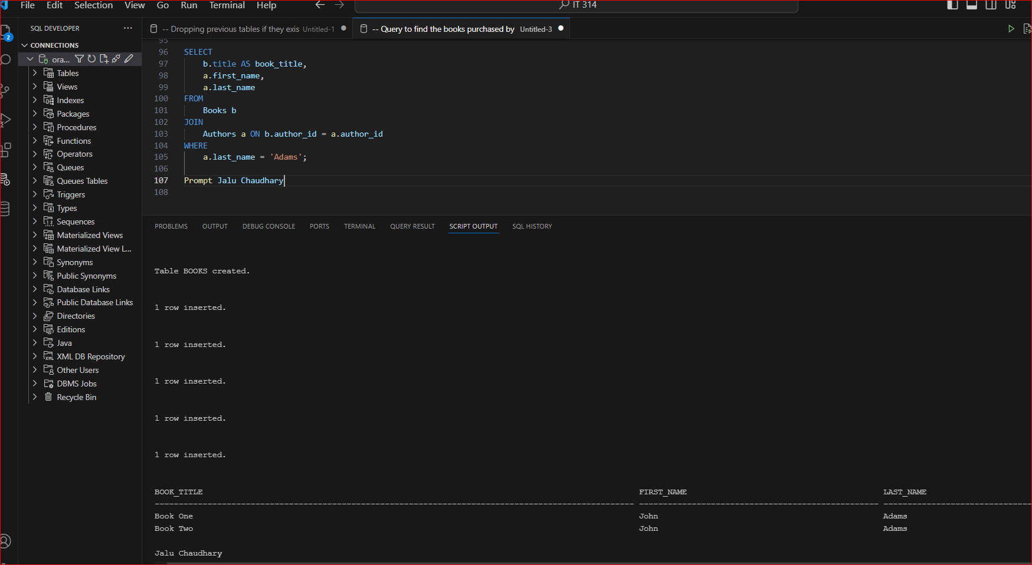

7. What gift will a customer who orders the book Shortest Poems receive? Use the actual

book retail value to determine the gift.

8. Identify the authors of the books Becca Nelson ordered. Perform the search using the

customer name.

9. Display a list of all books on the BOOKS table. If a book has been ordered by a customer,

also list the corresponding order number and the state in which the customer resides.

10. An EMPLOYEES table was added to the JustLee Books database to track employee

information. Display a list of each employee’s name, job title, and manager’s name. Use

column aliases to clearly identify employee and manager name values. Include allemployees in the list and sort by manager name.